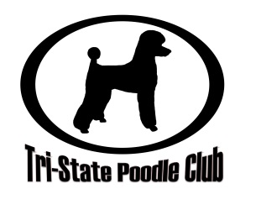
Photo Release Form

I hereby grant Tri-State Poodle Club permission to use my likeness and the likeness of my dogs in all photographs taken at any event hosted by or publicized through any venue of Tri-State Poodle Club in any and all of its publications, including but not limited to their website and Facebook entries, without payment or any other consideration.

I understand and agree that these materials will become the property of Tri-State Poodle Club and will not be returned.

I understand that I will not be notified at any time of the use of these materials. If at any time, however, I should become aware of their use electronically (ex. on the website or Facebook) and should wish to request that such use be discontinued in future electronic use, I may make that request to Tri-State Poodle Club with expectation that due consideration will be made to grant my request. I understand that the same considerations cannot be made for materials used in printed forms.

I hereby irrevocably authorize Tri-State Poodle Club to edit, alter, copy, exhibit, publish or distribute this photo for purposes of publicizing Tri-State Poodle Club’s programs or for any other lawful purpose. In addition, I waive the right to inspect or approve the finished product, including written or electronic copy, wherein my likeness appears. Additionally, I waive any right to royalties or other compensation arising or related to the use of the photograph.

I hereby hold harmless and release and forever discharge Tri-State Poodle Club from all claims, demands, and causes of action which I, my heirs, representatives, executors, administrators, or any other persons acting on my behalf or on behalf of my estate have or may have by reason of this authorization.

I am at least 21 years of age and am competent to contract in my own name. I have read this release before signing below and I fully understand the contents, meaning, and impact of this release.

(Signature) (Date)

(Printed Name) (Date)

If the person signing is under age 21, there must be consent by a parent or guardian, as follows:

I hereby certify that I am the parent or guardian of , named above, and do hereby give my consent without reservation to the foregoing on behalf of this person.

(Parent/Guardian’s Signature) (Date)

(Parent/Guardian’s Printed Name)

