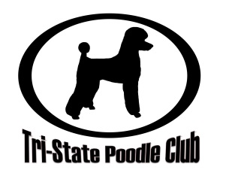
Tri-State Poodle Club and Outreach exists to promote and protect poodles in the Wisconsin, Iowa,
Illinois tri-state area through community, education, performance, and re-homing/rescue.

Household Events Liability and Photo Release

This liability and photo release is not specific to one event or date. Completing this release enters you in an agreement beginning the date of completion without a termination date. This agreement may be terminated at your request at any time by submitting your request in writing or by signing the termination line at the bottom of this form.

Today’s Date:

Names:

Mailing Address:

Email Address:

Phone Number:

I hereby grant Tri-State Poodle Club, Inc and Tri-State Poodle Club Outreach, Inc. permission to use my likeness and the likeness of my dogs in all photographs taken at any event hosted by or publicized through any venue of Tri-State Poodle Club in any and all of its publications, including but not limited to their website and Facebook entries, without payment or any other consideration.

In signing below, I hereby, for myself, my heirs, my executors and administrators, waive and release any and all rights and claims for damages that I may have against Tri-State Poodle Club, Inc. and Tri-State Poodle Club Outreach, Inc. and its agents, members, representatives, successors and assigns for any and all injuries suffered by myself, my dogs, or my possessions that arise out of Tri-State Poodle Club, Inc. or Tri-State Poodle Club Outreach, Inc. activities.

Signature(s):

